embedUR Systems
Campus Training Program – 2026
LINUX TRAINING – ASSESSMENT 2
Name : Muhesh M
College :Thiagarajar College of Engineering, Madurai.

- Use the appropriate command to list all files larger than 1 MB in the current directory and save the output to a file.

Commands:
- ls -l|awk ‘$5>1000000 {print $5 , $9}’ > q1/op.txt
- cat q1/op.txt

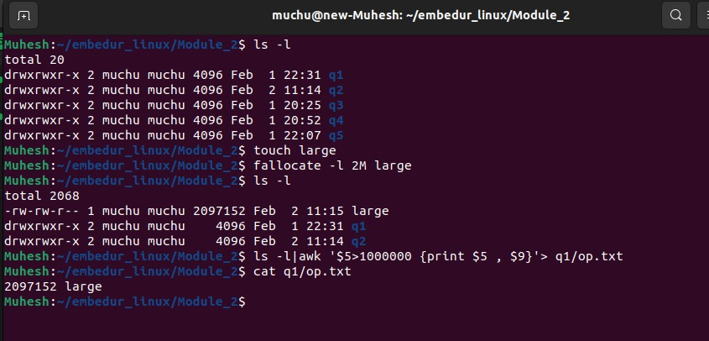

- Replace all occurrences of "localhost" with "127.0.0.1" in a configuration file named config.txt, and save the updated file as updated_config.txt.

Commands:
- sudo cp /etc/hosts config.txt
- cat config.txt
- sed ‘s\localhost\127.0.0.1\g’ config.txt > updated_config.txt.

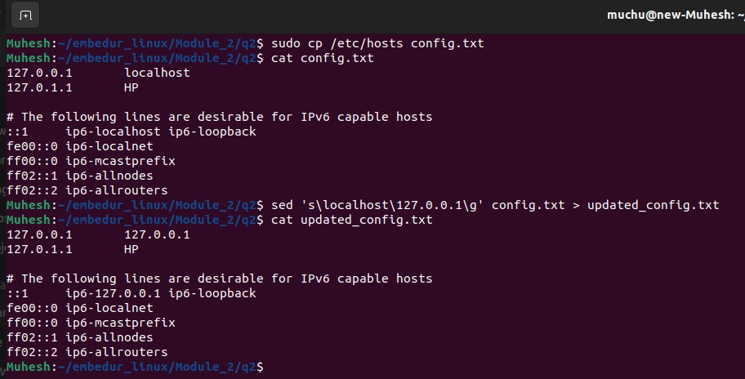

- Use the appropriate command to search for lines containing the word "ERROR" in a log file but exclude lines containing "DEBUG". Save the results to a file named filtered_log.txt.
Commands:
- nano log.txt
- grep “ERROR” log.txt|grep -v “DEBUG” > filtered_log.txt
- cat log.txt
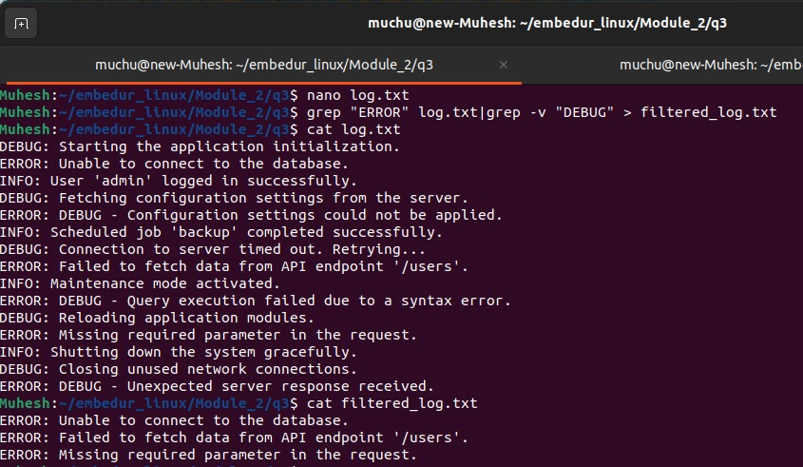
- cat filtered_log.txt
- Write a code to identify the process with the highest memory usage and then terminate it.
Commands:
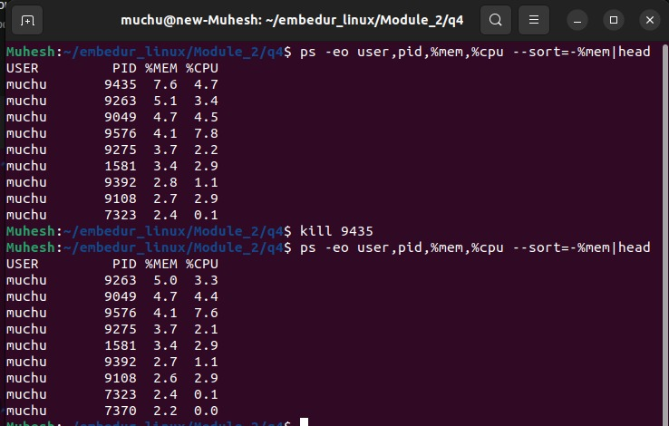
    - ps -eo user,pid,%mem,%cpu –sort=-%mem|head
    - kill 9435(PID)

- Use the networking tool command and print all the gateway available in a sorted manner.

Commands:

- ip route | awk ‘/default/{print $3}’ |sort
